

[**E-retail factors for customer activation and retention: A case study from Indian e-commerce customers**](https://www.researchgate.net/publication/346412647_E-retail_factors_for_customer_activation_and_retention_An_empirical_study_from_Indian_e-commerce_customers)

Submitted by:

SHAIK ALTHAFULLA

**ACKNOWLEDGMENT**

This includes mentioning of all the references, research papers, data sources, professionals and other resources that helped you and guided you in completion of the project.

References:

Github.com

Towardsscience.com

Scikit-learn.org

Kaggle.com

Stackoverflow, etc

Research papers: The papers can be studied kaggle and github studies papers and links.

Professionals and other resources: Data trained analytics partner and FLIPROBO Data analyst company.

Data source: The data is collected from the Indian online shoppers. Results indicate the e-retail success factors, which are very much critical for customer satisfaction.

**INTRODUCTION**

* Business Problem Framing

Customer satisfaction has emerged as one of the most important factors that guarantee the success of online store; it has been posited as a key stimulant of purchase, repurchase intentions and customer loyalty. A comprehensive review of the literature, theories and models have been carried out to propose the models for customer activation and customer retention. Five major factors that contributed to the success of an e-commerce store have been identified as: service quality, system quality, information quality, trust and net benefit. The research furthermore investigated the factors that influence the online customers repeat purchase intention. The combination of both utilitarian value and hedonistic values are needed to affect the repeat purchase intention (loyalty) positively. The data is collected from the Indian online shoppers. Results indicate the e-retail success factors, which are very much critical for customer satisfaction.

* Conceptual Background of the Domain Problem

Five major factors that contributed to the success of an e-commerce store have been identified as: service quality, system quality, information quality, trust and net benefit.

Results indicate the e-retail success factors, which are very much critical for customer satisfaction.

.

Review of Literature

Different data will be provided no null values are there lot of analysis and eda process after increasing data sufficient accuracy points to evaluate the metrics and design model.

**Analytical Problem Framing**

* Mathematical/ Analytical Modeling of the Problem

The mathematical, statistical and analytics modelling done during this project along with the proper justification.

Using some of libraries in python pandas, Numpy, seaborn and matplotlib and some metrics used

* Data Sources and their formats

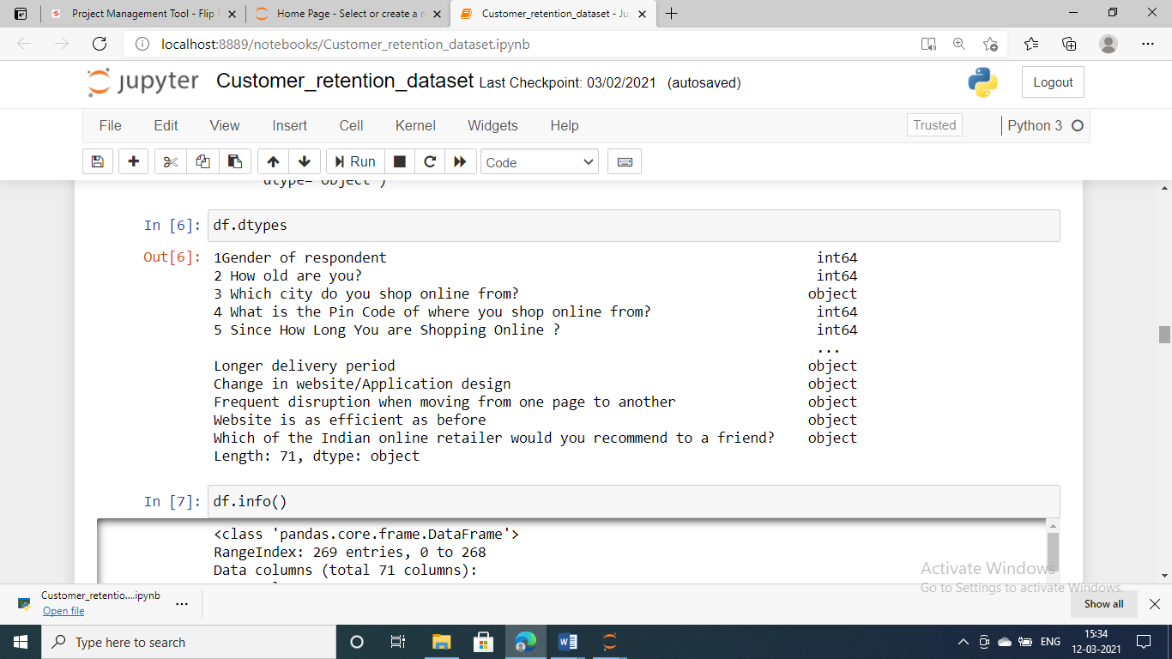

* Data Preprocessing Done

In this dataset there are no null values present.so EDA process can be done with with lot of procdure. The object oriented categorical data can be coverted by the valuable information. There is no effect on drop those columns..

Data Inputs- Logic- Output Relationships

All features of taken input

and target.

* Hardware and Software Requirements and Tools Used
* **Python**
* **Pandas libraries**
* **Numpy libraries**
* **Seaborn libraries**
* **Matplotlib.libraries**
* Key Metrics for success in solving problem under consideration
* Classification Metrics (**accuracy**, precision, recall, F1-score, ROC, AUC).
* Visualizations

All barplot diagrams cleanly observed and analysed the data

* Interpretation of the Results

The visualization and preprocessing models variables are important to predict the price of variable

These variables describe the price of the house

**CONCLUSION**

* Key Findings and Conclusions of the Study
* Data contains 269 entries each having 71variables.
* Data contains no Null values.
* Extensive EDA has to be performed to gain of important variables.
* Data contains numerical as well as categorical variable.
* Limitations of this work and Scope for Future Work

The data is increases the lot of visualization is different manner analysed